**LEBANESE AMERICAN UNIVERSITY**

**USAID – HIGHER EDUCATION SCHOLARSHIP PROGRAM**

**HES - Volunteering Program Verification Form**

This form is to be used to document volunteering hours. If a student volunteers for multiple organizations, a separate form must be used for each organization. **This form must be turned in by the 28th of each month, the latest.**

I certify that the scholar Maryam Swaiden completed a total of 9 hours of service at Life Sculptor.

The hours were completed hours as per the below:

Hours # 2 (date) _02/09 - 06/09_ (initials of supervisor) __A.K.___

Hours # 2 (date) _09/09 – 13/09_ (initials of supervisor) __A.K.___

Hours # 3 date) _16/09 – 20/09 (initials of supervisor) __A.K.___

Hours # 2 date) _23/09 – 27/09 (initials of supervisor) __A.K.___

Brief description of the activities the scholar performed or participated in:

- Attended workshop date assignment meeting  
- Contacted and coordinated with speakers for workshops each week  
- Edited powerpoint presentation for workshop   
- Placed workshops on the workshop calendar for end of 2024 and for 2025  
- Wrote short previews for each workshop topic of the month

Written feedback about the scholar’s performance:

Maryam Sweidan has played a key role in organizing workshops by coordinating with speakers, editing presentations, and scheduling events for the upcoming years, ensuring everything runs smoothly.

Please rate the overall performance of the scholar at your organization:

|  |  |  |  |
| --- | --- | --- | --- |
|  | Mastery (5) | Proficient (3) | Emerging (1) |
| **Problem solver** | X |  |  |
| **Engaged & Committed** | X |  |  |
| **Open-minded & multicultural** | X |  |  |

Signature

& stamp

__________________________

_

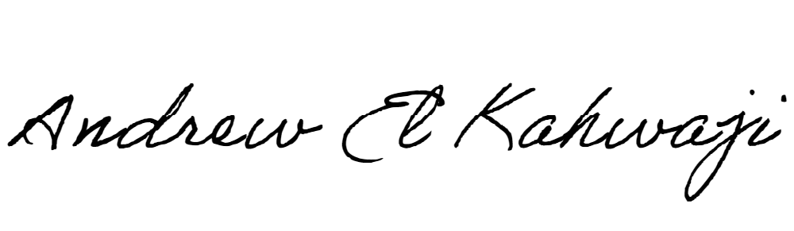

Printed Name _Andrew El Kahwaji_

Date __25/09/2024___

Email __andrew.lifesculptor.coo@gmail.com __

Phone __+961 71 914 378__

**LEBANESE AMERICAN UNIVERSITY**

**USAID – HIGHER EDUCATION SCHOLARSHIP PROGRAM**

